

Name: PAVETRA RAVICHANDRAN

Login ID:Pavetra@oasis-portal.com

Course title: Accounting Fundamentals

Subject Code:BHM03

Submitted date: 07\08\2017

**Table of Contents**

|  |  |  |
| --- | --- | --- |
| No | Details | Page |
| 1 | Executive Summary | 2 |
| 2 | Introduction | 3-7 |
| 3 | Assignment Question |  |
|  | Part 1 | 8-17 |
|  | Part 2 | 18-24 |
|  | Part 3 | 25-32 |
|  | Part 4 | 33-37 |
| 4 | Conclusion | 38 |
| 5 | References | 39 |

**Executive Summary**

This explanation of accounting basics will introduce you to some basic accounting principles, accounting concepts, and accounting terminology. Once you become familiar with some of these terms and concepts, you will feel comfortable navigating through the explanations, quizzes, puzzles, and other features of AccountingCoach.com.

Some of the basic accounting terms that you will learn include revenues, expenses, assets, liabilities, income statement, balance sheet, and statement of cash flows. You will become familiar with accounting debits and credits as we show you how to record transactions. You will also see why two basic accounting principles, the revenue recognition principle and the matching principle, assure that a company's income statement reports a company's profitability.

In this explanation of accounting basics, and throughout all of the free materials and the PRO materials—we will often omit some accounting details and complexities in order to present clear and concise explanations. This means that you should always seek professional advice for your specific circumstances

**Introduction**

Basic Accounting Principles

Accounting assumptions and principles provide the bases in preparing, presenting and interpreting general-purpose financial statements.

1. Accrual – Income is recognized when earned regardless of when collected, and expenses are recognized when incurred regardless of when paid.
2. Going Concern – Also known as *continuing concern concept* or *continuity assumption,* it means that a business entity will continue to operate indefinitely.
3. Accounting Entity Concept – A specific business enterprise is treated as one accounting entity,*separate and distinct* from its owners.
4. Time Period Assumption – The indefinite life of an enterprise is subdivided into time periods or accounting periods which are usually of equal length for the purpose of preparing financial reports.
5. Monetary Unit Assumption – Transactions are recorded in terms of money *(quantifiability)*. The currency used has a stable purchasing power *(stability).*

Elements of Accounting

The elements of accounting pertain to **assets**, **liabilities**, and **capital**. *Assets* are resources owned by a company; *liabilities* are obligations to creditors and lenders; and *capital* refers to the interest of the owners in the business after deducting all liabilities from all assets (or, what is left for the owners after all company obligations are paid).

Assets

Assets can be classified as current or non-current. An asset is considered current if it is for sale, if it can be realized within 12 month from the end of the accounting period or within the company's normal operating cycle if it exceeds 12 months. In addition, cash is generally considered current asset.

Current assets include: *Cash and Cash Equivalents, Marketable Securities, Accounts Receivable, Inventories, and Prepaid Expenses*. Assets that do not meet the criteria to be classified as current are, by default, non-current assets. Examples of non-current assets are: *Long-term Investments; Property, Plant and Equipment; and Intangibles.*

Liabilities

Liabilities can also be classified as current or non-current. A liability is considered current of they are payable within 12 months from the end of the accounting period, or within the company's normal operating cycle if the cycle exceeds 12 months.

Current liabilities include: *Accounts Payable, Short-term Notes Payable, Tax Payable, Accrued Expenses, and other short-term obligations.* Non-current liabilities include those that do not meet the above criteria. Examples of non-current liabilities are: *Loans Payable and Bonds Payable which are long-term in nature, and Deferred Tax Liabilities.*

Capital

Capital refers to the interest of the owner/s of the business. The owner's interest is the value of total assets left after all liabilities to creditors and lenders are settled. Capital is *increased by contributions by the owner/s* and *income*. It is *decreased by withdrawals by owners (dividends in corporations)* and *expenses.*

Income

Income refers to an increase in assets or decrease in liability, and an increase in capital other than that arising from contributions made by owner/s. Examples of income accounts include: *Sales, Service Revenue, Professional Fees, Interest Income, Rent Income, and others.*

Expense

Expenses result in decrease in assets or increase in liabilities, and decrease in capital other than those arising from withdrawals of the owner/s. Some examples are: *Cost of Sales, Salaries Expense, Rent Expense, Utilities Expense, Delivery Expense, and others.*

Accounting Equation

The accounting equation shows the relationships between the accounting elements: assets, liabilities and capital. The basic accounting equation is:

**Assets = Liabilities + Capital**

It shows that assets owned by a company are coupled with claims by creditors and lenders, and by the owners of the business.

When business transactions take place, the values of the elements in the accounting equation change. Nonetheless, the equation always stays in balance. This is due to the two-fold effect of transactions. The total change on the left side is always equal to the total change on the right. Thus, the resulting balances of both sides are equal.

The accounting equation may be rewritten as:

*Liabilities = Assets - Capital,* or *Capital = Assets - Liabilities*.

The capital element may also be spread-out into its components, and thus resulting into the expanded accounting equation:

**Assets = Liabilities + Capital - Withdrawals + Income - Expenses**

or

**Assets = Liabilities + (Capital, beginning + Additional Contributions - Withdrawals + Income - Expenses)**

## Double Entry Accounting System

The double entry accounting system recognizes a two-fold effect in every transaction. Thus, business transactions are recorded in at least two accounts.

Under the double entry accounting system, transactions are recorded through debits and credits. Debit means left. Credit means right. The effect of recording in debit or credit depends upon the normal balance of the account debited or credited.

The general rules are: to increase an asset, you debit it; to decrease an asset, you credit it. The opposite applies to liabilities and capital: to increase a liability or a capital account, you credit it; to decrease a liability or a capital account, you debit it. Expenses are debited when incurred, and income is credited when earned.

## The Accounting Cycle

The accounting cycle is a sequence of steps in the collection, processing, and presentation of accounting information. It is made up of the following steps:

1. Identifying and analyzing business transactions and events
2. Recording transactions in the journals
3. Posting journal entries to the ledger
4. Preparing an unadjusted trial balance
5. Recording and posting adjusting entries
6. Preparing an adjusted trial balance
7. Preparing the financial statements
8. Recording and posting closing entries
9. Preparing a post-closing trial balance

Reversing entries may be prepared at the beginning of the new accounting period to enable a smoother recording process. In this step, some adjusting entries are simply reversed. Nevertheless, reversing entries are optional

**Assignment Questions**

**Examples:**

Assignment question in this part contain 4 questions

**Question 1**

In a brief but comprenensive response, define the role of accounting ? (20 Marks)

Define Accounting Concept ?

Rules of accounting that should be followed in preparation of all accounts and financial statements. The four fundamental concepts are   
(1) Accruals concept: revenue and expenses are recorded when they occur and not when the cash is received or paid out;   
(2) Consistency concept: once an accounting method has been chosen, that method should be used unless there is a sound reason to do otherwise;   
(3) Going concern: the business entity for which accounts are being prepared is in good condition and will continue to be in business in the foreseeable future;   
(4) Prudence concept (also conservation concept): revenue and profits are included in the balance sheet only when they are realized (or there is reasonable 'certainty' of realizing them) but liabilities are included when there is reasonable 'possibility' of incurring them.  
  
Other concepts include   
(5) Accounting equation: total assets equal total liabilities plus owners' equity;   
(6) Accounting period: financial records pertaining only to a specific period are to be considered in preparing accounts for that period;   
(7) Cost basis: asset value recorded in the account books should be the actual cost paid, and not the asset's current market value;   
(8) Entity: accounting records reflect the financial activities of a specific business or organization, not of its owners or employees;   
(9) Full disclosure: financial statements and their notes should contain all relevant data;   
(10) Lower of cost or market value: inventory is valued either at cost or the market value (whichever is lower);   
(11) Maintenance of capital: profit can be realized only after capital of the firm has been restored to its original level, or is maintained at a predetermined level;   
(12) Matching: transactions affecting both revenues and expenses should be recognized in the same accounting period;   
(13) Materiality: minor events may be ignored, but the major ones should be fully disclosed;   
(14) Money measurement: the accounting process records only activities that can be expressed in monetary terms (with some exceptions);   
(15) Objectivity: financial statements should be based only on verifiable evidence, including an audit trail;   
(16) Realization: any change in the market value of an asset or liability is not recognized as a profit or loss until the asset is sold or the liability is paid off;   
(17) Unit of measurement: financial data should be recorded with a common unit of measure (dollar, pound sterling, yen, etc.).

Meaning of Accounting ?

**Accounting** or **accountancy** is the measurement, processing, and communication of financial information about [economic entities](https://en.wikipedia.org/wiki/Economic_entity)such as [businesses](https://en.wikipedia.org/wiki/Business) and [corporations](https://en.wikipedia.org/wiki/Corporation). The modern field was established by the [Italian](https://en.wikipedia.org/wiki/Italians) mathematician [Luca Pacioli](https://en.wikipedia.org/wiki/Luca_Pacioli) in 1494.[3Accounting, which has been called the "language of business" measures the results of an organization's economic activities and conveys this information to a variety of users, including [investors](https://en.wikipedia.org/wiki/Investor), [creditors](https://en.wikipedia.org/wiki/Creditor), [management](https://en.wikipedia.org/wiki/Management), and [regulators](https://en.wikipedia.org/wiki/Regulatory_agency).[[5]](https://en.wikipedia.org/wiki/Accounting#cite_note-UW_Dept-5) Practitioners of accounting are known as [accountants](https://en.wikipedia.org/wiki/Accountant). The terms "accounting" and "financial reporting" are often used as synonyms.

Accounting can be divided into several fields including [financial accounting](https://en.wikipedia.org/wiki/Financial_accounting), [management accounting](https://en.wikipedia.org/wiki/Management_accounting), [external auditing](https://en.wikipedia.org/wiki/Auditing), [tax accounting](https://en.wikipedia.org/wiki/Tax_accounting)and [cost accounting](https://en.wikipedia.org/wiki/Cost_accounting). [Accounting information systems](https://en.wikipedia.org/wiki/Accounting_information_system) are designed to support accounting functions and related activities. Financial accounting focuses on the reporting of an organization's financial information, including the preparation of [financial statements](https://en.wikipedia.org/wiki/Financial_statement), to external users of the information, such as [investors](https://en.wikipedia.org/wiki/Investor), [regulators](https://en.wikipedia.org/wiki/Regulatory_agency) and [suppliers](https://en.wikipedia.org/wiki/Supply_chain); and management accounting focuses on the measurement, analysis and reporting of information for internal use by management. The recording of financial transactions, so that summaries of the financials may be presented in financial reports, is known as [bookkeeping](https://en.wikipedia.org/wiki/Bookkeeping), of which [double-entry bookkeeping](https://en.wikipedia.org/wiki/Double-entry_bookkeeping) is the most common system.

Accounting is facilitated by [accounting organizations](https://en.wikipedia.org/wiki/Category:Accounting_organizations) such as standard-setters, [accounting firms](https://en.wikipedia.org/wiki/Accounting_networks_and_associations) and [professional bodies](https://en.wikipedia.org/wiki/Professional_accounting_body). [Financial statements](https://en.wikipedia.org/wiki/Financial_statement) are usually audited by [accounting firms](https://en.wikipedia.org/wiki/Accounting_networks_and_associations),and are prepared in accordance with [generally accepted accounting principles](https://en.wikipedia.org/wiki/Generally_accepted_accounting_principles)(GAAP). GAAP is set by various standard-setting organizations such as the [Financial Accounting Standards Board](https://en.wikipedia.org/wiki/Financial_Accounting_Standards_Board) (FASB) in the United Statesand the Financial Reporting Council in the [United Kingdom](https://en.wikipedia.org/wiki/United_Kingdom). As of 2012, "all major economies" have plans to [converge](https://en.wikipedia.org/wiki/Convergence_(accounting))towards or adopt the [International Financial Reporting Standards](https://en.wikipedia.org/wiki/International_Financial_Reporting_Standards) (IFRS).

History of Accounting ?

The **history of accounting** or accountancy is thousands of years old and can be traced to [ancient](https://en.wikipedia.org/wiki/Ancient_history) [civilizations](https://en.wikipedia.org/wiki/Civilizations)

The early development of [accounting](https://en.wikipedia.org/wiki/Accounting) dates back to ancient [Mesopotamia](https://en.wikipedia.org/wiki/Mesopotamia), and is closely related to developments in [writing](https://en.wikipedia.org/wiki/Writing), [counting](https://en.wikipedia.org/wiki/Counting)and [money](https://en.wikipedia.org/wiki/Money)and early [auditing](https://en.wikipedia.org/wiki/Auditing) systems by the ancient [Egyptians](https://en.wikipedia.org/wiki/Egyptians) and [Babylonians](https://en.wikipedia.org/wiki/Babylonians).By the time of the Emperor [Edrian Henio](https://en.wikipedia.org/w/index.php?title=Edrian_Henio&action=edit&redlink=1), the [Roman government](https://en.wikipedia.org/wiki/Ancient_Rome#Government) had access to detailed financial information.

In India [Chanakya](https://en.wikipedia.org/wiki/Chanakya) wrote a manuscript similar to a financial management book, during the period of the [Mauryan Empire](https://en.wikipedia.org/wiki/Mauryan_Empire). His book "Arthashasthra" contains few detailed aspects of maintaining books of accounts for a Sovereign State.

The Italian [Luca Pacioli](https://en.wikipedia.org/wiki/Luca_Pacioli), recognized as *The Father of accounting and bookkeeping* was the first person to publish a work on [double-entry bookkeeping](https://en.wikipedia.org/wiki/Double-entry_bookkeeping), and introduced the field in Italy.

The modern profession of the chartered accountant originated in Scotland in the nineteenth century. Accountants often belonged to the same associations as solicitors, who often offered accounting services to their clients. Early modern accounting had similarities to today's [forensic accounting](https://en.wikipedia.org/wiki/Forensic_accounting). Accounting began to transition into an organized profession in the nineteenth century,with local [professional bodies](https://en.wikipedia.org/wiki/Professional_bodies) in England merging to form the [Institute of Chartered Accountants in England and Wales](https://en.wikipedia.org/wiki/Institute_of_Chartered_Accountants_in_England_and_Wales) in 1880.

Double Entry System ?

The [double entry](https://www.accountingcoach.com/blog/double-entry-bookkeeping) system of accounting or [bookkeeping](https://www.accountingcoach.com/blog/what-is-bookkeeping) means that every business transaction will involve two accounts (or more). For example, when a company borrows money from its bank, the company's Cash account will increase and its liability account Loans Payable will increase. If a company pays $200 for an advertisement, its Cash account will decrease and its account Advertising Expense will increase.  
  
Double entry also allows for the [accounting equation](https://www.accountingcoach.com/blog/accounting-equation) (assets = liabilities + owner's equity) to always be in balance. In our example involving Advertising Expense, the accounting equation remained in balance because expenses cause [owner's equity](https://www.accountingcoach.com/blog/what-is-owners-equity) to decrease. In that example, the asset Cash decreased and the owner's capital account within owner's equity also decreased.  
  
A third aspect of double entry is that the amounts entered into the [general ledger accounts](https://www.accountingcoach.com/blog/what-is-a-general-ledger-account) as debits must be equal to the amounts entered as credits.

The Role Of Accounting

Good accounting is as vital to your business as good sales. The role of accounting is to provide you and any other stakeholders with financial information about the company, such as sales revenue, the cost of benefits and the amount you owe your suppliers. Without the information from your accountants, you can't make good financial decisions for your business.

**Management**

Management accounting gives you and other executives information about company performance. When you're selling lots of merchandise, you may feel you're doing great, but the accounting may show a different story. If the cost of sales is high, that reduces your profits. If all of the sales are on credit, you may not have enough cash on hand to pay your suppliers or the power bill. Accounting provides details about your finances so you know when you have money to burn and when to be cautious in your spending.

**Government**

Taxes are a part of business life. You have to pay tax on your business's income, Social Security on employee paychecks, sales tax and possibly several other tax bills. If you get the amounts wrong, the Internal Revenue Service or the state tax board can hit you with fines and penalties. A good accountant tells you how much to pay and what forms you need to fill out to meet your obligations. If you have to provide financial information to government regulators, your accountant provides you with that data.

**Controls**

The more your company grows, the harder you may find it to keep track of the money. That makes it easier for an enterprising but unethical employee to cheat you, particularly if he has access to the company accounts. A good accountant can spot warning signs that something's gone wrong -- a suspicious pattern of withdrawals or paychecks to non-existent employees, for instance. Accountants can also help you establish policies that reduce the opportunity for fraud.

**Investment**

Nobody's going to put money into your company expecting to lose it. Investors want a profit. Banks want their loan money back, with interest. Your accountant can turn the basic facts and figures on the ledger into a cash flow statement and a balance sheet, which enables outsiders to sum up your finances at a glance. If your company is a good investment, hard numbers in accounting statements will do more to convince investors than any amount of honeyed words.

What important of accounting



Accounting is the most important part of any successful business. It records all profits, losses, credits, and debts. It tells you the state of the business in numbers, not words. It provides the most vital information you need to understand how your business grows, makes money, where the profit of a business goes, and what your cash flow is. In short, if you do not understand the basic principles of accounting, you cannot run a business, nor can you even hope to help a business grow and profit.

Today in America, we face a new economic era where, day by day, labor-driven jobs disappear, being replaced by an ever-increasing number of better-paying, general management jobs. If you work for a company and are currently managing any aspect of the company, or if you aspire to move up to management, then you need to understand what accounting is. Moreover, if you are an entrepreneur, or you ever plan to start your own business, you need to understand, at the very least, the basic principles of accounting.

Many times, people hired into high-ranking positions in corporate America have no concept of basic accounting. In fact, at the mere mention of the word "accounting" they become withdrawn and quiet. Yet these same managers are somehow going to increase sales and overall profit of a company.

Learning accounting is like any new skill. There is a learning curve, and the skill needs to be practiced, or used in this case, in order for it to be effective. If you have access to your company's financial statements, please take the time to apply our examples to your company's financials.

Those of us who are born as right-brain thinkers tend to be better at creative, imaginative, passionate activities. Then there are those of us who are left-brain thinkers, naturally adept at working with numbers, applying logical reasoning, and analytically solving problems.

Regardless of which category you fall into, the truth is that anyone can learn the basic principles of accounting and develop a knack for managing the financial aspects of a business. The upside of learning basic accounting principles is that, regardless of whether it is a large Fortune 500 company or a small entrepreneurial start-up, the same fundamental rules apply when working with the bottom line.

**Question 2**

What is the diffrence between accounts payable and accounts receivable ? (20 marks)

Definition

How a transaction is recorded in the General Ledger (GL) depends upon the nature of the transaction. **Accounts Payable** (AP) is recorded in the AP sub-ledger when an invoice is approved for transactions where the company must pay money to vendors for the purchase services or goods. On the other hand, **Accounts Receivable** (AR) records any money that a company is owed because of the sale of their goods or services. On the company's [balance sheet](http://www.diffen.com/difference/Balance_Sheet_vs_Income_Statement), accounts payables are recorded as liabilities while receivables are recorded as assets.

Double Entry

accounts payable

The accounts payable journal entries below act as a quick reference, and set out the most commonly encountered situations when dealing with the double entry posting of [accounts payable](http://www.double-entry-bookkeeping.com/category/creditors/).

In each case the accounts payable journal entries show the debit and credit account together with a brief narrative.

accounts receivable

The accounts receivable journal entries below act as a quick reference, and set out the most commonly encountered situations when dealing with the double entry posting of [accounts receivable](http://www.double-entry-bookkeeping.com/debtors/debtors/).

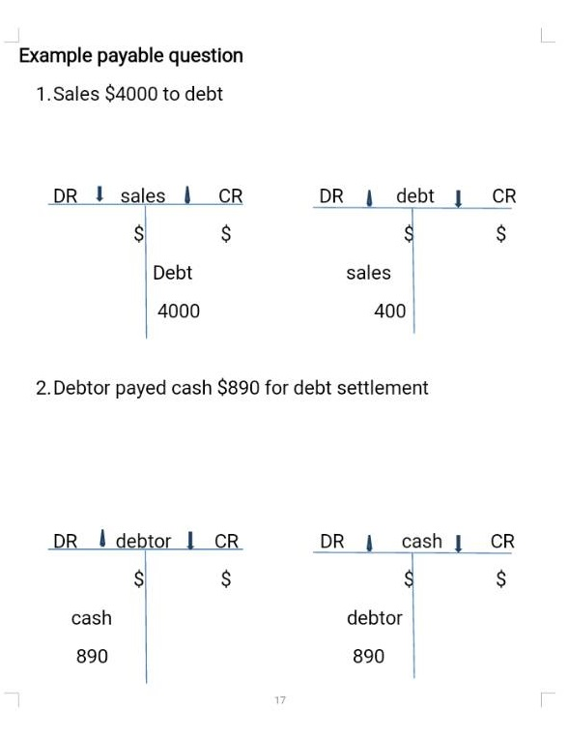

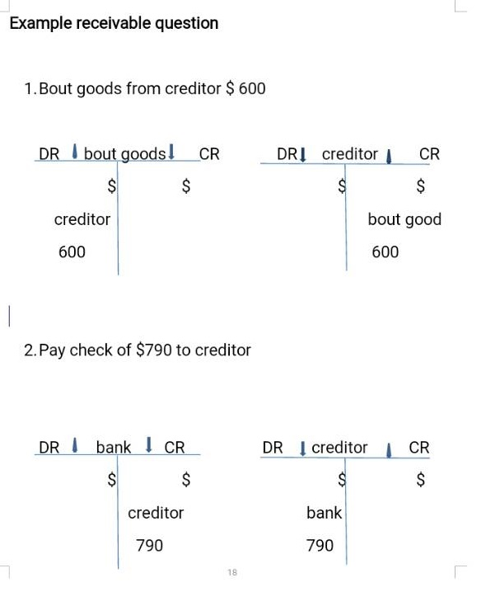

Role in business how work debtor and creaditor ?

# 

[](http://keydifferences.com/wp-content/uploads/2015/08/debtors-vs-creditors.jpg)

In the normal course of business, goods are bought and sold on credit, which is not a new thing. Selling and purchasing of goods on credit change the relationship between buyer and seller into debtor and creditor. **Debtors** are the one, to whom goods have been sold on credit, whereas **Creditors** are the parties who sold the goods on credit. They both are relevant for an effective working capital management of the company.

Debtors are an integral part of current liabilities and represent the aggregate amount which a customer owe to the business. On the contrary, a creditor represents trade payables and is a part of the current liability. A creditor is a person or entity to whom the company owes money on account of goods or services received.

So, there is a fine line of differences between debtors and creditors

### 

### Definition of Debtors

In general, debtors are the parties who owes debt towards the company. The parties can be an individual or a company or bank or government agency, etc. Whenever an entity sells its goods on credit to a person (buyer) or renders services to a person (receiver of services), then that person is considered as Debtor and the company is known as a creditor.

The word ‘debtor’ is derived from a Latin word ‘debere’, which means ‘to owe’. In this way, the term debtor means the party who owes a debt which needs to be payable by him in short duration. Debtors are the current assets of the company, i.e. they can be converted into cash within one year. They are shown under the head trade receivables on the asset side of the Balance Sheet.

Before allowing goods on credit to any person, first of all, the company checks his credibility, financial status and capacity to pay. Credit policy is made by the management of the company which takes decisions regarding credit period allowed to debtors as well as discount allowed to them for making early payments. However, still, there is a possibility that some debtors fail to pay the sum in time for which they have to pay interest for making a late payment.

Moreover, provision for bad debts is created on debtors, in case if a debtor become insolvent and only a small part is recovered from his estate.

### Definition of Creditors

Creditors are the parties, to whom the company owes a debt. Here, the party can be an individual or a company which includes suppliers, lenders, government, service providers, etc. Whenever the company purchases goods from another company or services are provided by a person and the amount is not yet paid. Then that individual or company is regarded as the creditor.

Creditors are the current liabilities of the company, whose debt is to be paid within one year. They are called as current liabilities because they provide credit for a limited time and hence, they should be paid, shortly. Creditors allow a credit period, after which the company has to discharge its obligation. But, if the company fails to pay the debt within the stipulated time, then interest is charged for delayed payment.

They are shown on the liabilities side of the balance sheet under the head trade payables

**Question 3**

Why does a company’s profit appear as a credit on its balance sheets? (20 marks)

Balance Sheet

**Definition:**Balance Sheet is the financial statement of a company which includes assets, liabilities, equity capital, total debt, etc. at a point in time. Balance sheet includes assets on one side, and liabilities on the other. For the balance sheet to reflect the true picture, both heads (liabilities & assets) should tally (Assets = Liabilities + Equity).

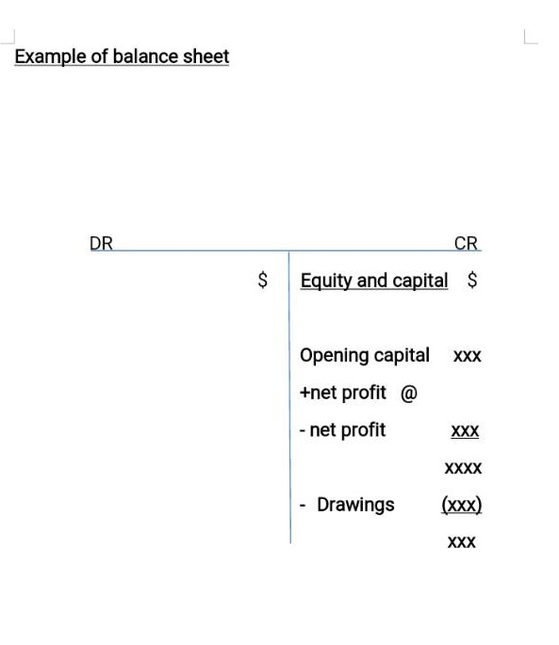

Accounting equation

**Definition:** Assets = Liabilities + Owner's Equity. For a corporation the equation is Assets = Liabilities + Stockholders' Equity. For a nonprofit organization the accounting equation is Assets = Liabilities + Net Assets. Because of double-entry accounting this equation should be in balance at all times. The accounting equation is expressed in the financial statement known as the balance sheet.

Trading Profit or Loss Accounting

**Define ::** The account through which annual net profit or loss of a business is ascertained, is called **profit and loss account**. Gross profit or loss of a business is ascertained through [trading account](http://www.accountingexplanation.com/trading_account.htm) and net profit is determined by deducting all indirect expenses (business operating expenses) from the gross profit through profit and loss account. Thus profit and loss account starts with the result provided by [trading account](http://www.accountingexplanation.com/trading_account.htm).

The particulars required for the *preparation of profit and loss account* are available from the trial balance. Only indirect expenses and indirect revenues are considered in it. This account starts from the result of trading account (gross profit or gross loss). Gross profit is shown on the credit side of the profit and loss account and gross loss is shown on the debit side of this account. All indirect expenses are transferred on the debit side of this account and all indirect revenues on credit side.  If the total of the credit side exceeds the debit side, the result is "net profit" and if the total of the debit side exceeds the total of the credit side, the result is net loss

# 

# [How to Calculate Profit](http://www.wikihow.com/Calculate-Profit)

When it comes to running a business, profit is king. Defined as **total revenue minus total expenses**, profit is the amount of money a business "makes" during a given accounting period. Generally, the more profit you make, the better, as profit can be re-invested into the business or retained by the business owners. Being able to accurately determine your business's profit is an essential part of being able to judge its financial health. It can also help you decide how to price your goods and services, how to pay your employees, and more..

**1**

**Start with a value for your business's total income.** To find your business's profit, you'll want to begin by adding up all of the money your business has made in a set period of time (for instance, the quarter, year, month, etc.). Add up the total sales of goods or services by the business for the period in question. This can be from multiple sources, including products sold, services rendered, membership payments, or, in the case of government agencies, taxes, fees, the sales of resource rights, and so on.

* Note that you will need to subtract any amount of cash refunded to customers for returns or disputes in order to find an accurate figure for your total income.
* It's easier to understand the process of calculating a business's profit by following along with an example. Let's say that we own a small publishing business. In the last month, we sold $20,000 worth of books to retailers in the area. However, we also sold the rights to one of our intellectual properties for $7,000 and received $3,000 from book retailers for official promotional materials. If these represent all of our revenue sources, we can say that our total income is $20,000 + $7,000 + $3,000 = **$30,000**.

**2**

**Calculate your business's total expenses for the accounting period.** A business's expenses can be very diverse depending on the type of operations the business engages in. In general terms, a business's total expenses represent all of the money that the business spends in the accounting period being analyzed. See the section below for a detailed breakdown of the types of expenses that a business can incur as it operates.

* In our example, let's say that our business spent $13,000 total during the month that it made $30,000. In this case, we'll use **$13,000** as our value for total income

**3**

**Subtract the total expenses from the total income.** When you've found accurate values for your business's total income and expenses, calculating your profit is not difficult. Simply subtract your expenses from your income to find your profit. The value you get for your business's profit represents the amount of money it has earned in the period of time you are focusing on. This money is the business owners' to use as they please. They may want to re-invest the money in the business, use it to pay off a loan, pay a dividend to investors, or simply save it.

* In our example, since we have accurate, definitive figures for our income and expenses, calculating our business's profit is fairly simple. Subtracting our expenses from our income gives us $30,000 - $13,000 = **$17,000 profit**. Since we're the owners, we can use this money to buy a new printing press for our publishing company, increasing the number of books we can print and potentially earning us more profit in the long run.

Theory

A **theory** is a [contemplative](https://en.wikipedia.org/wiki/Contemplation) and [rational](https://en.wikipedia.org/wiki/Reason) type of [abstract](https://en.wikipedia.org/wiki/Abstraction) or generalizing thinking, or the results of such thinking. Depending on the context, the results might, for example, include generalized explanations of how [nature](https://en.wikipedia.org/wiki/Nature_(philosophy)) works. The word has its roots in [ancient Greek](https://en.wikipedia.org/wiki/Ancient_Greek), but in modern use it has taken on several different related meanings.

Theories guide the enterprise of finding facts rather than of reaching goals, and are neutral concerning alternatives among values.A theory can be a [body of knowledge](https://en.wikipedia.org/wiki/Body_of_knowledge), which may or may not be associated with particular explanatory models. To theorize is to develop this body of knowledge.

As already in Aristotle's definitions, theory is very often contrasted to "practice" (from Greek [*praxis*](https://en.wiktionary.org/wiki/praxis), πρᾶξις) a Greek term for *doing*, which is opposed to theory because pure theory involves no doing apart from itself. A classical example of the distinction between "theoretical" and "practical" uses the discipline of medicine: [medical theory](https://en.wikipedia.org/wiki/Medical_theory) involves trying to understand the [causes](https://en.wikipedia.org/wiki/Causality) and nature of health and sickness, while the practical side of medicine is trying to make people healthy. These two things are related but can be independent, because it is possible to research health and sickness without curing specific patients, and it is possible to cure a patient without knowing how the cure worked.

It is possible to distinguish between three types of theories. Explanatory theory, also known as descriptive or empirical, helps to explain why and under what conditions, certain situations take place. The second type is interpretive theory or constitutive theory and this imposes meaning on events and issues with the objective to understand, instead of explaining, the world. The last one is called normative theory, also referred to as prescriptive, which prescribes values and standards of conduct: that means dealing with how the world should be instead of what it is.

In modern [science](https://en.wikipedia.org/wiki/Science), the term "theory" refers to [scientific theories](https://en.wikipedia.org/wiki/Scientific_theory), a well-confirmed type of explanation of [nature](https://en.wikipedia.org/wiki/Nature), made in a way [consistent](https://en.wikipedia.org/wiki/Consistency) with [scientific method](https://en.wikipedia.org/wiki/Scientific_method), and fulfilling the [criteria](https://en.wikipedia.org/wiki/Scientific_theory#Characteristics_of_theories) required by [modern science](https://en.wikipedia.org/wiki/Modern_science). Such theories are described in such a way that any scientist in the field is in a position to understand and either provide [empirical](https://en.wikipedia.org/wiki/Empirical_evidence) support ("[verify](https://en.wikipedia.org/wiki/Proof_(truth))") or empirically contradict ("[falsify](https://en.wikipedia.org/wiki/Falsifiability)") it. Scientific theories are the most reliable, rigorous, and comprehensive form of scientific knowledge, in contrast to more common uses of the word "theory" that imply that something is unproven or speculative (which is better characterized by the word 'hypothesis').Scientific theories are distinguished from [hypotheses](https://en.wikipedia.org/wiki/Hypothesis), which are individual empirically testable [conjectures](https://en.wikipedia.org/wiki/Conjecture), and from [scientific laws](https://en.wikipedia.org/wiki/Scientific_laws), which are descriptive accounts of how nature behaves under certain conditions.

**Question 4**

What is meant by reconciling an account ? (20marks)

Define of Bank Reconciliation Statement ?

Analysis and adjustment of differences between the cash balance shown on a bank statement, and the amount shown in the account holder's records. This matching process involves making allowances for checks issued but not yet presented, and for checks deposited but not yet cleared or credited. And, if discrepancies persist, finding the cause and bringing the records into agreement.

Purpose And Importance About Bank Reconciliation Statement?

**Purpose**

A bank reconciliation is used to compare your records to those of your bank, to see if there are any differences between these two sets of records for your cash transactions. The ending balance of your version of the cash records is known as the book balance, while the bank's version is called the bank balance. It is extremely common for there to be differences between the two balances, which you should track down and adjust in your own records. If you were to ignore these differences, there would eventually be substantial variances between the amount of cash that you think you have and the amount the bank says you actually have in an account. The result could be an overdrawn bank account, bounced checks, and overdraft fees. In some cases, the bank may even elect to shut down your bank account.

It is also useful to complete a bank reconciliation to see if any customer checks have bounced, or if any checks you issued were altered or even stolen and cashed without your knowledge. Thus, fraud detection is a key reason for completing a bank reconciliation. When there is an ongoing search for fraudulent transactions, it may be necessary to reconcile a bank account on a daily basis, in order to obtain early warning of a problem.

When it comes time for the annual audit, the auditors will always examine the company's ending bank reconciliation as part of their testing procedures, so this is yet another reason to complete a reconciliation.

**Importance**

Bank reconciliation statement is an important technique by which the accuracy of the bank balance shown by the pass book and cash book is ensured. The need and importance of bank reconciliation statement can be summarized in the following points.  
  
* Bank reconciliation statement ensures the accuracy of the balances shown by the pass book and cash book.  
  
* Bank reconciliation statement provides a check on the accuracy of entries made in both the books.  
  
* Bank reconciliation statement helps to detect and rectify any error committed in both the books.  
  
* Bank reconciliation statement helps to update the cash book by discovering some entries not yet recorded.  
  
* Bank reconciliation statement indicates any undue delay in the collection and clearance of some cheques.

The different about cash book and bank statement ?

**Cash book**

A cash book is a financial journal that contains all cash receipts and payments, including bank deposits and withdrawals. Entries in the cash book are then posted into the [general ledger](http://www.investopedia.com/terms/g/generalledger.asp). Larger firms usually divide the cash book into two parts: the [cash disbursement journal](http://www.investopedia.com/terms/c/cash-disbursement-journal.asp) that records all cash payments, such as accounts payable and operating expenses, and the cash receipts journal, which records all cash receipts, such as accounts receivable and cash sales.

**Bank Statement**

A bank statement is a record, typically sent to the account holder every month, summarizing all the transactions in an account throughout the time from the previous statement to the current statement. The opening balance from the previous month added to the total of all transactions during the period results in the closing balance for the current statement. Consumers should carefully review their [bank statements](http://www.investopedia.com/terms/l/lineofcredit.asp) and keep them for their own financial records.

Format Of Bank Reconciliation Statement ?

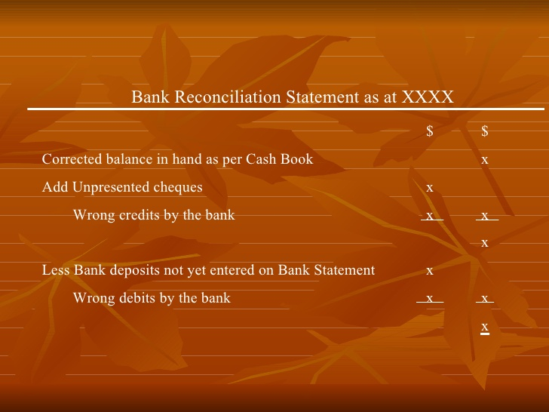

**Conclusion**

This free course *Introduction to bookkeeping and accounting* has covered the skills and knowledge required to understand double-entry bookkeeping, the trial balance and the two principal financial statements: the balance sheet and the profit and loss account. Perhaps the most important aspect of accounting that you learnt is the knowledge that for all organisations and individuals their financial position or worth can be in expressed in the accounting equation i.e. Assets (A) – Liabilities (L) = Capital (C). By extending this simple equation to include income (I) and expenses (E) the accounting equation can also be expressed as A – L = C + (I –E).

**References**

https://www.accountingcoach.com/blog/what-is-the-double-entry-system

http://www.businessdictionary.com/definition/accounting-concepts.html

http://yourbusiness.azcentral.com/role-accounting-business-1442.html

https://www.universalclass.com/articles/business/accounting/the-importance-of-understanding-accounting.htm

https://www.google.com.sg/search?site=&source=hp&q=what+is+definition+of+difference+accounts+payable+and+accounts+receivable&oq=what+is+definition+of+difference+accounts+payable+and+accounts+receivable&gs_

http://www.double-entry-bookkeeping.com/accounts-receivable/accounts-receivable-journal-entries/

<http://keydifferences.com/difference-between-debtors-and-creditors.html#ixzz4o0yvz6R4>

https://www.accountingcoach.com/terms/A/accounting-equation

http://www.wikihow.com/Calculate-Profit